Date of publication 2025.05, 2025, date of current version 0001 05, 2025.

Digital Object Identifier 10.1109/ACCESS.2024.Doi Number

CyberWebX: An Intelligent Cybersecurity Platform Using ML and OSINT

Ahmet Yiğit1, Emre Oytun2, and Elif Deniz3

1Gebze Technical University, Gebze, Kocaeli TR

2Gebze Technical University, Gebze, Kocaeli TR

3Gebze Technical University, Gebze, Kocaeli TR

Corresponding author: Ahmet Yigit (e-mail: a.yigit2020@gtu.edu.tr).

ABSTRACT Today, individuals and organizations face increasing risks from cyber threats such as malware, suspicious domains, and weak passwords. These threats may result in data breaches, system vulnerabilities, and identity theft. In this study, we present an integrated web-based security tool that consists of three main components: (1) a Portable Executable (PE) file analysis module for static malware detection using header-based features and Random Forest classification, (2) a domain trust detection system that utilizes token-based URL analysis with Logistic Regression, and (3) an OSINT-based user profiling tool that generates strong passwords with the help of a Large Language Model (LLM). The system includes a unified user interface built with HTML, CSS, and JavaScript, and a Flask-based backend API. By enabling early threat detection and secure password suggestions, the proposed system aims to enhance user safety and provide a practical solution against common cyber attack vectors.

INDEX TERMS Keywords: Malware detection, Random Forest, Logistic Regression, OSINT, cybersecurity, password generation.

1. INTRODUCTION

With digital technology becoming a big part of our daily lives, people and companies now face more online security problems—like harmful software, fake websites, and weak or stolen passwords. Traditional security tools often can’t catch new or tricky threats such as unknown viruses or lookalike websites. To help solve this problem, we created a lightweight and easy-to-use web platform called CyberWebX. It includes three smart tools that use machine learning: file analysis, domain checking, and password suggestions.

The first tool checks Windows files (called PE files) without opening them. It uses Python to look at file details like section size and time of creation. These details are then analyzed using a Random Forest model to say if the file is safe or dangerous. This makes the system fast and safe, since files don’t need to be run.

The second tool looks at website links (URLs) to see if they might be fake or used for phishing. Instead of checking DNS data, it looks at things like how long the URL is, how many numbers it has, and whether it includes words like “verify” or “secure.” It uses TF-IDF and a Logistic Regression model to guess if the link is safe. Trusted websites (like Gmail) are added to a safe list and skipped.

The third tool helps users create strong passwords. It uses public data like usernames and emails (collected through scraping) to make smart, personal password ideas. A local AI model (LLM) creates passwords that are strong but still easy to remember. It also checks if the password has been leaked before, using a local version of “Have I Been Pwned.”

All these tools are available on one website. The user interface is made with HTML, CSS, and JavaScript. The system runs on a Flask backend, and each tool can work alone or together. The goal is to give users a simple and helpful way to protect themselves online, without needing deep technical knowledge.

The full system setup, showing how data flows between parts of the system, is shown in Figure 1.

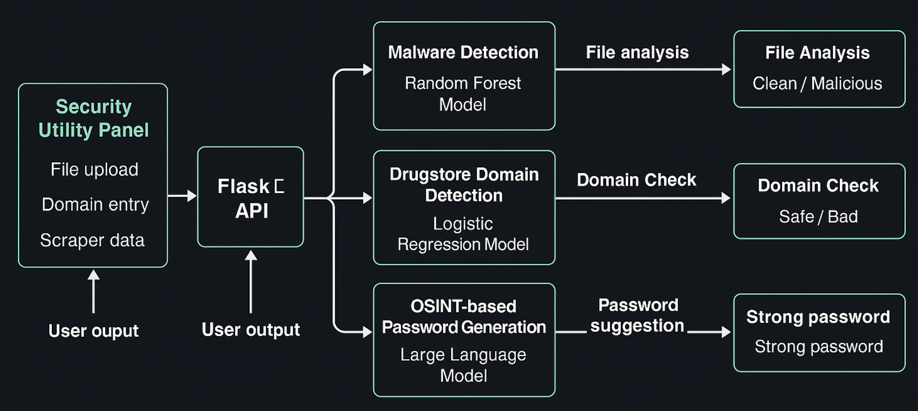

FIGURE 1. General architecture of the CyberWebX system

1. BACKGROUND

As cyber threats continue to grow in number and complexity, people and organizations need smarter tools to stay protected online. Traditional security software, such as basic antivirus programs or systems that follow fixed rules, are often not enough to detect modern attacks. These attacks include advanced malware that changes its form, fake websites designed for phishing, and stolen or weak passwords. For this reason, many experts recommend using machine learning (ML) to improve cybersecurity. ML helps systems find patterns in data and make more accurate decisions.

Our project introduces a system that uses machine learning in three different ways to improve online safety. One part of the system focuses on Windows files, specifically PE (Portable Executable) files. It checks these files without running them. By using a Python tool, it reads important details such as file size and structure. These details are then sent to a machine learning model called Random Forest, which decides if the file is harmful or safe. Because the files are not executed, this method is both fast and secure. Also, previous studies show that this kind of static file analysis is effective and reliable.

Another part of the system looks at website links (URLs) to find out if they are safe. It does not use complex network data like WHOIS or DNS records. Instead, it checks simple things such as how long the URL is, how many digits it includes, and whether it contains suspicious words like “verify” or “secure.” These features are used to create a text-based profile of the URL, and then a Logistic Regression model is used to classify it as safe or dangerous. This method works well and is supported by research. Although advanced data sources are not used in the current version, the system is designed to easily add them in the future.

The third part of the system helps users create strong and personalized passwords. Users can paste public information such as usernames or email addresses into a web form. A local AI model (Large Language Model – LLM) uses this input to generate password suggestions that are strong but still easy to remember. Because the model runs locally, no personal data is sent to the internet, which helps protect user privacy. This idea is based on research showing that public digital information can help users avoid weak and guessable passwords.

Most cybersecurity tools focus on just one area, such as detecting viruses or checking website links. Our system, CyberWebX, combines three tools in a single web platform: malware detection, domain trust evaluation, and password generation. Each tool can work alone, but when used together, they provide stronger and more complete protection. In the future, we plan to expand the system by adding features like breach database checking and integration of WHOIS data. This would help the platform become even more useful in fighting modern cyber threats.

1. METHODOLOGIES

3.1 Malware File Detection: Header-Based Analysis

* 1. Machine Learning Classification

In the CyberWebX system, the PE Analysis Module helps decide if a Windows Portable Executable (PE) file is safe or dangerous. To keep things secure, it doesn’t run the file. Instead, it looks at the file’s internal structure—this is called static analysis. Since the file is never executed, this approach is both faster and safer. We use a machine learning model called Random Forest, which is known for working well with organized data and giving high accuracy.

To train this model, we created a dataset of 10,000 PE files, where half were malicious and the other half were safe. The malicious files came from public malware sources on Kaggle, and the safe ones were taken from trusted Windows folders and software. Before training, we manually checked the files to remove duplicates, fix errors, and make sure both classes were balanced.

We used a Python library called pefile to collect information from each file without opening or running them. This tool helps extract key features that may indicate suspicious behavior. The features we used include:

• Number of sections

• Machine type

• Time and date stamp

• Symbol table pointer

• Entropy of sections

• Number of imported functions

These features often look different in malicious files, especially in those that are obfuscated or compressed to hide their true purpose. We also normalized all the values before training so the model could learn better.

Next, we divided the data into two parts: 80% for training the model and 20% for testing it. We used Scikit-learn’s Random Forest with its default settings. Although we didn’t use advanced tuning methods like Grid Search or K-Fold, the model still gave strong results:

• Accuracy: 95.8%

• Precision: 94.6%

• Recall: 93.2%

• F1 Score: 93.9%

These numbers show that the model is very good at recognizing both safe and harmful files, and it rarely makes mistakes. It also works well on new files that it hasn’t seen before.

Finally, we saved the trained model using joblib and connected it to a Flask-based API. This allows users to upload PE files on the CyberWebX website and get real-time feedback about whether the file is safe or not.

* 1. Feature Extraction from Headers

In our system, static features were collected from each PE file using the pefile library in Python. This tool helps read important metadata from the file without running it. While not every technical field is listed in detail, we focused on key parts of the file that are commonly linked to suspicious behavior.

The selected features include:

• Machine type

• Time and date stamp

• Number of sections

• Pointer to symbol table

• File characteristics

• Section entropy

• Number of imported functions

These features were chosen because they help spot patterns often found in harmful files. For example, when a file has very high or very low entropy, it might be packed or encrypted—two tricks used by malware to avoid being detected. Similarly, a file with unusual timestamps or very few imported functions may be trying to hide its real purpose.

To make our model more effective, we also added some extra structural features. All feature values were normalized before training. This step helps keep the learning process fair by making sure no one feature has more influence just because of its scale. Normalization also improves the model’s overall accuracy and stability.

An overview of this full process—from feature extraction to final prediction—can be seen in Figure 2.

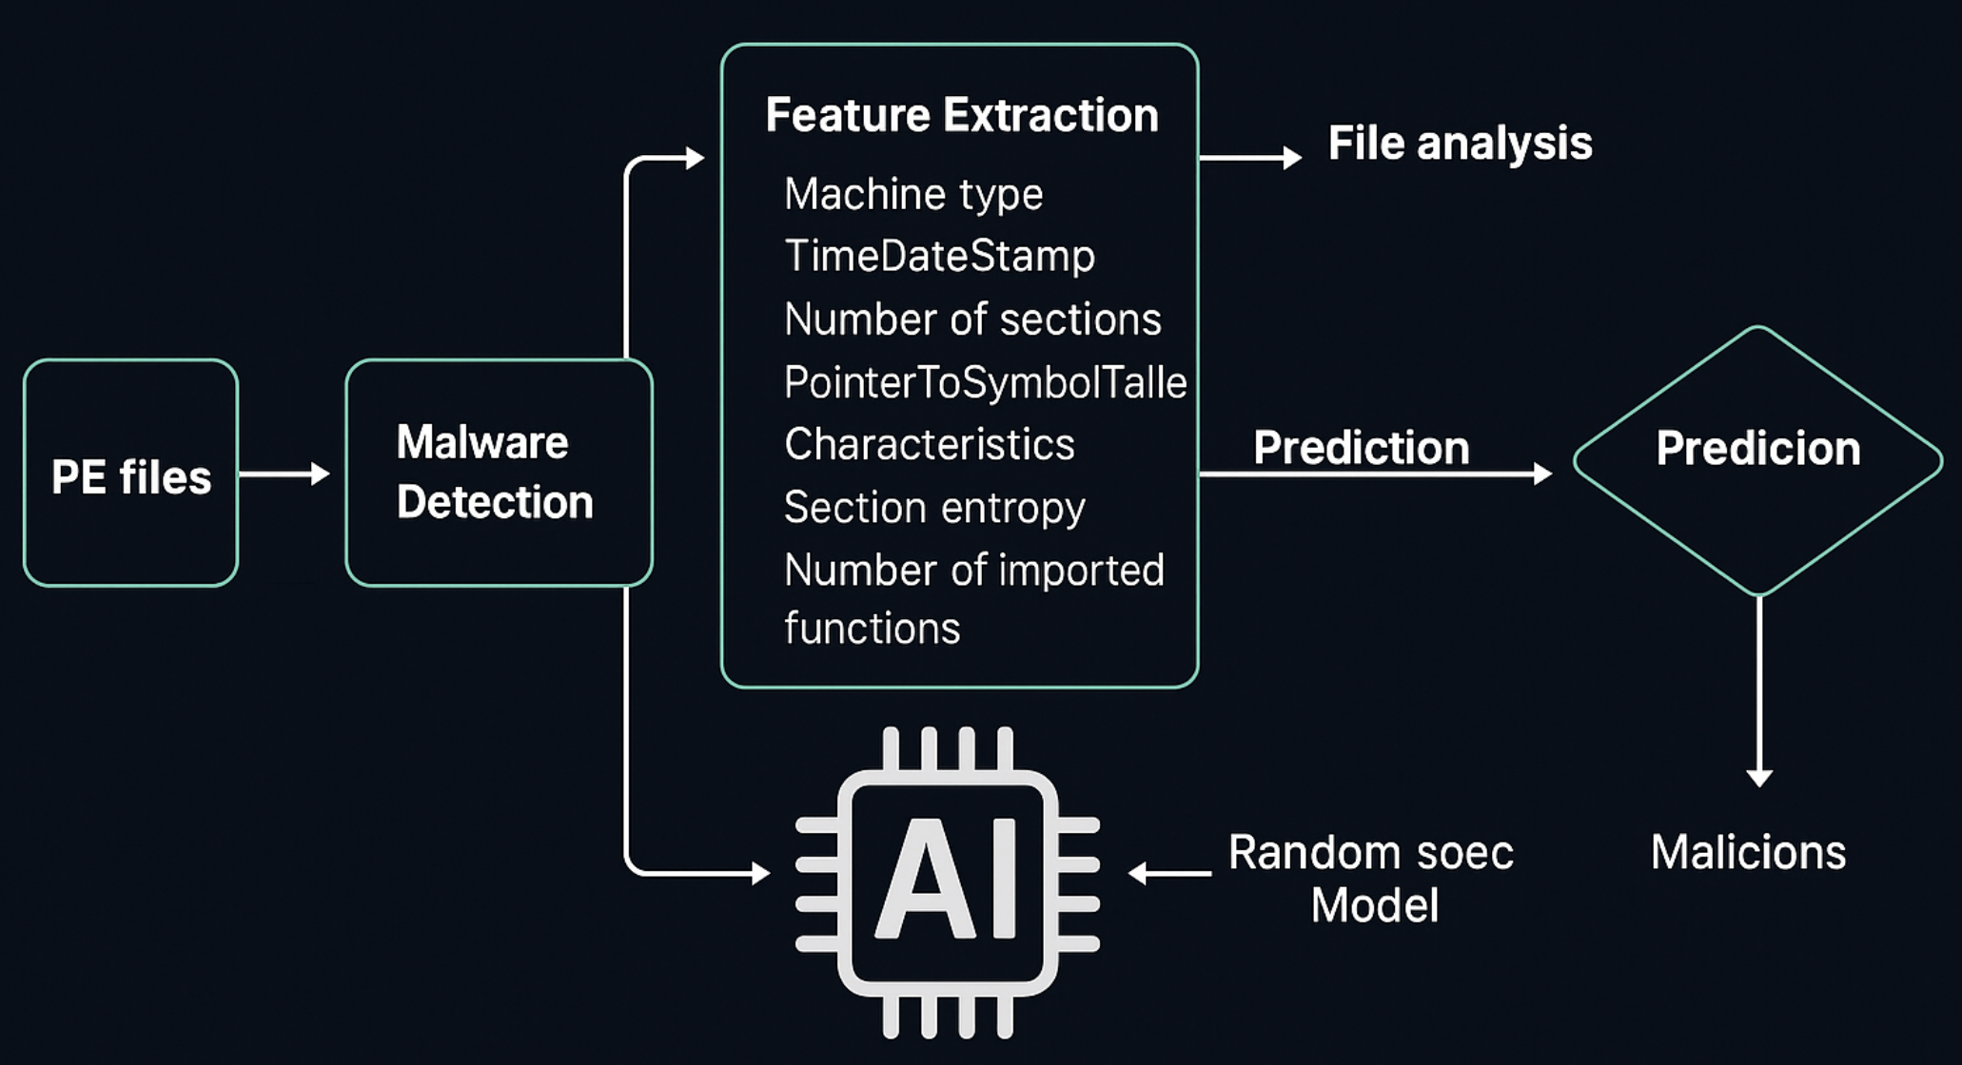

FIGURE 2. Header-Based Malware Detection Pipeline in CyberWebX Framework

3.2 Domain Trust Detection: Malicious URL Analysis

1. Data Preprocessing and Cleaning

This module helps detect dangerous websites by looking closely at how the web address (URL) is written. It uses a dataset of 84,093 labeled domain names, collected from trusted phishing sources like PhishTank and OpenDNS. Each web address in the dataset is marked as either malicious (dangerous) or benign (safe).

Before training the machine learning model, the dataset goes through a cleaning process. Duplicate URLs are removed, all letters are made lowercase, and extra symbols are taken out. If a URL is broken or missing parts, it is also removed. After this, the data is split randomly: 70% is used for training, and 30% is used for testing. This helps the model learn fairly and get tested properly.

The system looks at basic text features from the domain names. It does not use external tools or services to collect extra data. The features include: • Length of the domain

• Number of dots (shows subdomains)

• Whether the domain is written as a numeric IP address

• Use of common phishing words like “login”, “verify”, “secure”, or “account”

At the moment, the system does not use extra information like WHOIS data (such as when the domain was created or who owns it). However, the system is designed in a flexible way, so these features can be easily added later to make the detection even stronger.

1. Text Feature Extraction and Model Training

To prepare the domain names for machine learning, we first broke them into smaller parts (called tokens) and turned them into numbers using TF-IDF (Term Frequency-Inverse Document Frequency). This method helps show which parts of a domain are more useful for telling the difference between malicious and safe websites.

Next, we trained a Logistic Regression model using these TF-IDF values. We used the Scikit-learn library in Python to build the model. The data was split carefully using stratified sampling, so that the number of malicious and safe samples stayed balanced in both training and testing sets.

The model performed very well, with the following results:

• Accuracy: 98.57%

• Precision: 98.11%

• Recall: 99.60%

• AUC Score: 0.9988

These results show that the model can clearly tell the difference between dangerous and safe URLs. It also keeps false alarms and missed threats very low.

All the training and testing steps were done in Python using Jupyter Notebooks. After training, the model was added to the CyberWebX system using a Flask-based API. Thanks to this setup, the system can check new URLs in real time and warn users if a domain looks suspicious.

1. Whitelisting Mechanism

To prevent false positives from affecting popular or trusted domains, a lightweight whitelisting mechanism is implemented. This bypasses classification for domains matching known safe suffixes like .gov, .edu, or other explicitly whitelisted entries. The module checks incoming domains against this list before invoking the model.

While external DNS Blacklist (DNSBL) checks and WHOIS enrichment are not yet operational, the modularity of the backend makes such enhancements easy to integrate. The complete architecture of the URL classification module—including preprocessing, TF-IDF feature extraction, classification using Logistic Regression, and whitelisting logic—is illustrated in Figure 3.

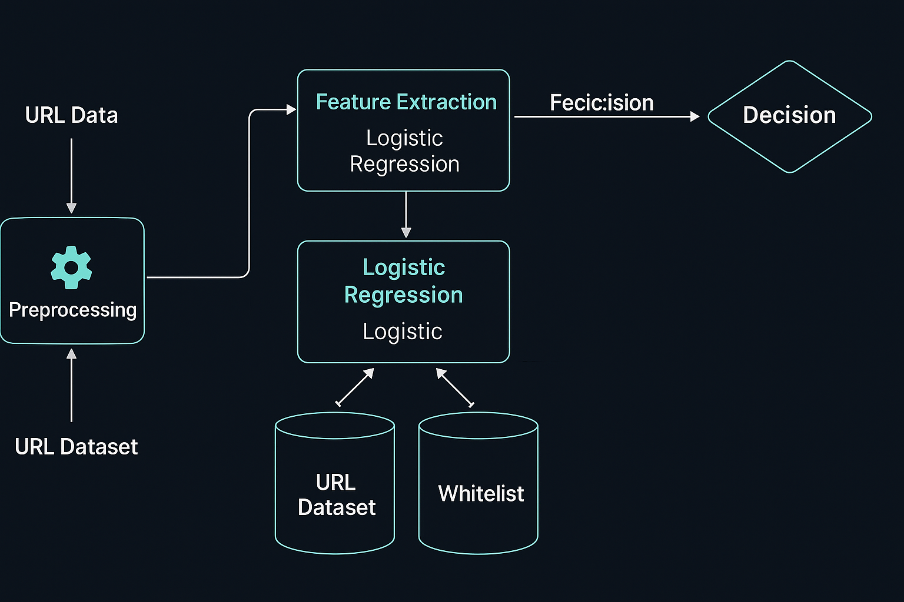

FIGURE 3. Workflow of the domain trust detection module including preprocessing, feature extraction, classification, and whitelisting.

3.3 OSINT-Based User Data Collection and Password Generation

1. Open-Source Intelligence (OSINT) Framework

In the third module of the CyberWebX system, Open-Source Intelligence (OSINT) techniques are used to collect publicly available user data and build a digital footprint. This footprint helps generate personalized security recommendations and strong passwords. The OSINT functionality is implemented using Python libraries such as requests, BeautifulSoup, and Tkinter, and is presented to the user as a standalone GUI application (guimain.py). The scraping scripts run locally to ensure data privacy and avoid transmitting sensitive information over the internet.

The scraper collects metadata from a variety of sources, including:

• GitHub profiles

• LinkedIn and Twitter pages (via Selenium)

• Instagram profiles (via Instaloader)

• PGP key directories

• General web search results

The collected data includes:

• Usernames

• Full names (if available)

• Email addresses (from public profiles or keys)

• Organizational affiliations

• Profile activity metadata

This information is structured into a JSON-like format and can be used directly by the password generator module. The goal is to capture behavioral patterns or identity clues that might affect password strength.

The GUI is designed for ease of use by non-technical users. It allows the user to:

• Enter a target username

• Choose platforms to scrape

• Start the scraping process with one click

• View progress and results in real time

• Export collected data to a .txt file or send it to the main CyberWebX interface

Local execution of the tool increases speed, avoids rate limits, and ensures that no third-party services handle user data during scraping.

1. LLM-Based Strong Password Generation

After collecting basic online information about a user, the system generates strong and personalized passwords using an AI language model. Unlike many other solutions that depend on cloud services, this password generator runs locally via a Flask API. This approach ensures that no user data is sent online, helping protect privacy and security.

The process begins when user data is submitted to the /generate-password endpoint. The system then creates a structured prompt using the user’s digital profile and sends it to the Gemini AI model. Gemini generates 500 password suggestions that are strong, diverse, and easy to remember.

The system follows current password safety standards:

• Each password has a minimum length of 12 characters

• A combination of uppercase, lowercase, numbers, and symbols is used

• Personal details like names or birthdates are generally excluded

• Passwords use patterns such as camelCase, symbol replacements, and random structures to increase strength Before showing the results, each password is evaluated using several quality checks:

• Entropy – to measure randomness and strength

• Structure – to analyze how characters are arranged

• Guessability – to avoid common or easily guessed words

To improve security further, each password is compared against a local database of known leaked passwords. This comparison is done offline and does not require an internet connection.

Once the evaluation is complete, users can view the results through a simple web interface. The interface includes:

• A list of recommended passwords

• Color bars to indicate the strength of each suggestion

• Useful security tips, such as enabling two-factor authentication (2FA) or using password managers

Currently, the system performs well in test environments and is scalable for larger use. Future improvements include:

• Real-time feedback during password typing

• Smarter AI responses based on user profiles

• A fully offline version that works without any network access

The complete password generation workflow is shown in Figure 4.

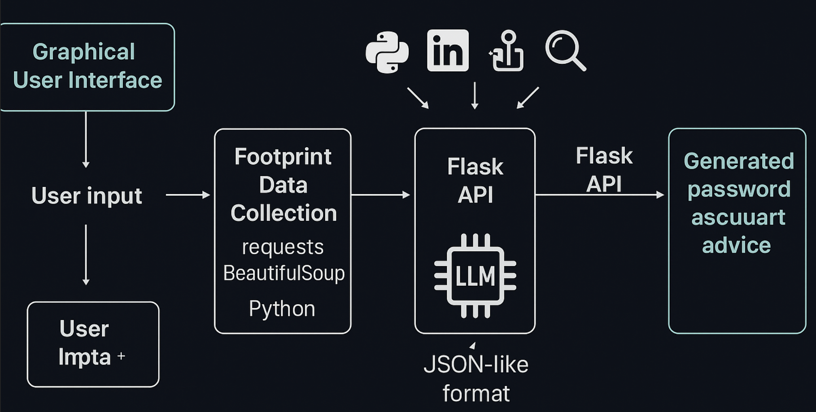

FIGURE 4. Architecture of the OSINT module for user footprint analysis and password generation

1. DATASET AND PREPROCESSING

This project uses two labeled datasets sourced from Kaggle to train and evaluate the machine learning models in both the malware and URL classification modules.

4.1 PE Header Dataset

For this module, we used the Malware Dataset [4], which includes labeled Windows PE files. From this dataset, we selected 10,000 files: 5,000 safe (benign) and 5,000 harmful (malicious).

Before using the data, we did some basic cleaning. Files that could not be read were removed.

Then, we normalized important file features such as:

• Entropy (how random the file content is)

• Number of sections in the file

• Number of imported functions

After cleaning, we split the dataset into two parts:

• 80% for training the model

• 20% for testing the model

We used the pefile library in Python to extract useful information from each file. This tool reads the file’s static (non-running) parts, like headers and imports, which are important for detecting malware.

4.2 URL Dataset

This module uses the Benign and Malicious URLs dataset [5], which includes more than 84,000 domain names. After removing duplicate and broken entries, we cleaned the data and extracted some simple features from each domain. These features include:

• Length of the domain

• Number of subdomains (dots in the address)

• Use of common phishing keywords like “login” or “secure”

To prepare the data for machine learning, we used TF-IDF vectorization, which changes text into numbers. This helps the model understand which parts of the domain are more important.

We then split the dataset:

• 70% for training the model

• 30% for testing it

Right now, we only use basic text-based features. However, more advanced features like WHOIS information (domain age, owner, etc.) and DNS blacklists can be added later, because the system is built in a flexible way.

1. IMPLEMENTATION DETAILS

5.1 Backend – Flask API’s

The backend layer of the CyberWebX system is developed using Flask, a lightweight and flexible Python web framework ideal for building RESTful APIs. The purpose of this backend is to serve as the core communication layer between the machine learning models, preprocessing utilities, and user-facing interfaces (both web and desktop). Each of the three main detection modules in the project is linked to its own dedicated Flask API endpoint, allowing modular and scalable interactions.

a. Malware File Detection Endpoint

The first backend route is used to check if a PE (Portable Executable) file is safe or not. When a user uploads a file using the website or an API, the Flask server saves it temporarily.

After saving, the system uses the pefile library to read important static features from the file. These features include:

• Machine type

• Number of sections

• Entropy (how random the data is)

• Number of imported functions

These features are sent into a Random Forest model that was trained earlier. This model is already loaded into memory when the application starts (using Python’s joblib library).

The model checks the file and gives a result:

• Malicious (harmful) or

• Benign (safe)

This result is sent back to the user in JSON format. The route also includes safety checks:

• It makes sure the uploaded file is the right type and size

• It handles errors if the file is broken or not a real PE file

b. Domain Trust Detection Endpoint

The second endpoint is used to detect if a website link (URL) might be harmful or not. The system accepts one URL or a list of domain names as input.

First, the system cleans the input text:

• It removes extra spaces,

• Changes all letters to lowercase,

• And deletes any characters that are not allowed.

After this, the cleaned text is converted into numbers using a method called TF-IDF. This method was trained before and saved, so it can be used quickly during prediction.

The result from TF-IDF is then sent to a Logistic Regression model, which was also trained and saved before. This model gives two outputs:

• A label (safe or malicious),

• And a score showing how sure the model is.

This part of the system works fast and can check many URLs at the same time. Also, there is a whitelist function that checks if the domain ends with trusted endings like .gov or .edu. If so, the system may skip further checks to reduce false alarms.

c. OSINT and Password Generation Endpoint

The third and most interactive part of the system is used for creating passwords from user data. This happens when the user enters their information using a web page or a desktop application built with Tkinter. The frontend sends this information in JSON format, which may include details like the user’s name, username, email address, and workplace.

Before using this information, the system first cleans it to remove any unnecessary or unsafe content. Then, the cleaned data is sent to a large language model (LLM), which can work either inside the Flask backend or as a separate process. This model generates several password suggestions that follow strong password rules. These rules include having at least 12 characters and using a mix of uppercase and lowercase letters, numbers, and special symbols.

After the passwords are generated, the backend checks how strong each password is. It uses entropy calculations to measure randomness and also uses rule-based scoring methods to rate the quality of the passwords.

In the backend, each task—like PE file analysis, URL classification, and password generation—is handled in its own function. This makes the code more organized and easier to maintain. All backend parts use common tools such as logging to keep track of system activity, error tracking to detect problems, and performance monitoring to measure how fast the system runs.

The Flask backend also uses CORS, which helps the frontend and backend communicate smoothly, even if they are on different ports. This is especially helpful during testing or development.

Finally, the backend is built in a modular way. This means it can be improved easily in the future. New features like user login with JWT, model updates, or integration with cloud platforms such as AWS or Google Cloud can be added with little effort.

5.2 Frontend – UI & UX Design

The frontend interface of the CyberWebX platform is designed as a responsive web-based dashboard that facilitates seamless interaction between the user and the backend services. Developed using HTML, CSS, and JavaScript, the interface focuses on simplicity, speed, and usability across different modules of the system.

* 1. Design Objectives

The main goal of the design was to make sure that users can use all parts of the system—like uploading a file to check for malware, analyzing a website, or creating strong passwords—without needing any technical background.

The user interface is simple and clear. Every part of the screen is designed to be easy to understand. Buttons have different colors depending on what they do, so users know which one to click. Also, the system gives instant feedback while the user types or submits something. This helps users know what’s happening and what to do next.

* 1. Module-Specific User Interaction

Each module has its own section on the dashboard:

• Malware File Detection: Users can upload .exe or .dll files via a drag-and-drop zone or traditional file picker. Once uploaded, the file is sent to the Flask backend, and the prediction results (e.g., “Benign” or “Malicious”) are displayed instantly along with relevant probability scores (see Figure 5).

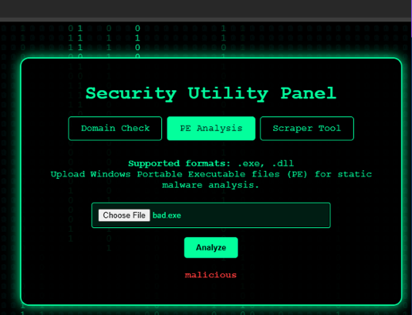

Figure 5.Malware File Detection interface displaying the analysis result of an uploaded PE file.

• Domain Trust Detection: Users can input a single domain or paste a list of domains for batch evaluation. Results are presented in a clean, scrollable table, with malicious domains highlighted for attention. A whitelist status tag is also included where applicable (see Figure 6).

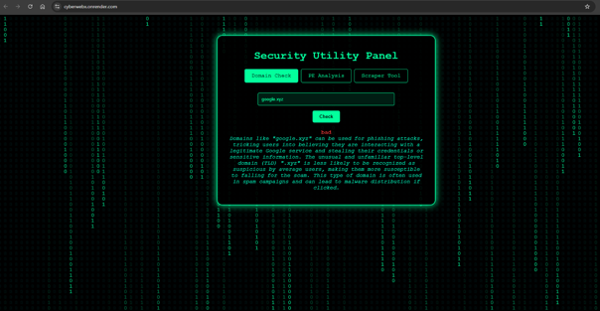

Figure 6. Screenshot of the Domain Trust Detection interface showing the result for a suspicious domain (“google.xyz”).

• OSINT-Based Password Tool: The frontend provides an input box for pasting user profile data collected via the Tkinter GUI. Upon submission, generated password suggestions appear alongside entropy scores and password strength indicators. Helpful tips and visual cues (e.g., green/red bars) guide users in selecting strong passwords (see Figure 7).

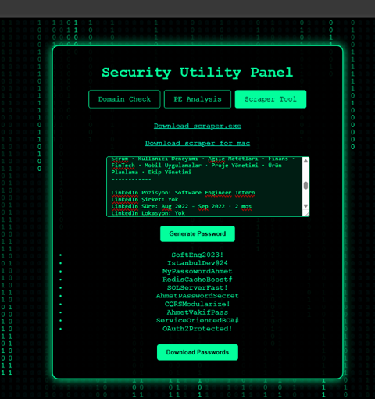

Figure 7. Interface of the OSINT-based password generator showing input data and generated secure passwords with visual strength feedback.

* 1. Responsiveness and Usability

The frontend layout is mobile-responsive and adapts to various screen sizes. Users can access the system through both desktop and mobile browsers without loss of functionality. Error handling is implemented to catch missing inputs, unsupported file formats, or failed API calls, ensuring a smooth user experience.

* 1. Integration with Backend

The frontend communicates with the Flask backend through AJAX requests and RESTful APIs. Each module is modularized with separate routes to avoid interface clutter and to maintain separation of concerns in frontend logic.

Overall, the UI & UX design successfully bridges technical backend processes with an accessible user interface, enabling efficient cybersecurity interactions for both technical and non-technical users.

5.3 GUI Password Generator – Tkinter

The third interface layer in the CyberWebX system is implemented as a standalone desktop application using Tkinter, Python’s standard GUI toolkit. This module operates independently from the web dashboard and is specifically designed to perform Open-Source Intelligence (OSINT) data collection and initiate local password generation workflows.

a. GUI Architecture and Purpose

The graphical user interface (GUI), developed in the guimain.py script, allows users to collect digital footprint data on their local machine in a simple and user-friendly way. It is especially helpful for users who do not have technical experience or are unfamiliar with command-line tools.

The main purpose of this GUI is to gather publicly available user information from the internet. It collects details such as usernames, email addresses, short bios, and references to workplaces or organizations. These details are gathered using scraping techniques and then organized into a clean and usable format, which is later used for password generation.

The interface includes several easy-to-use features. Users can enter the username of the target person in a dedicated input field. They can also select one or more platforms to search from options like GitHub, LinkedIn, or Pastebin. With a single click, the scraping process begins. Once the process is complete, the structured information appears on the screen in a readable format. Users can view this data directly or copy it easily for further use.

After data collection, the structured information is saved locally on the user’s device. If desired, this data can also be sent directly to the Flask API, which handles the password generation process.

1. Tkinter Design and User Flow

The Tkinter window contains:

* Entry widgets for username input
* Checkboxes for platform selection
* Progress indicator and console-like feedback area
* Text box displaying the final JSON-formatted footprint

This design enables real-time monitoring of the scraping process, including success/failure messages for each data source. Users can inspect and manually edit the result before triggering password generation.

1. Security and Privacy Considerations

Unlike cloud-based scrapers, the Tkinter-based GUI runs fully locally, ensuring that no user or target data is sent to external services during the footprinting stage. This architectural choice enhances both data privacy and compliance with ethical standards in cybersecurity applications.

Additionally, all scraping scripts are limited to publicly accessible metadata and do not perform authentication-based or invasive operations. The GUI serves educational, experimental, and defensive purposes in controlled environments.

1. Password Generation Trigger

Once the footprint data is prepared, the user can paste it into the web interface of the main CyberWebX system or send it directly to the backend via local API. The backend LLM module then uses this input to generate secure and personalized password suggestions. This local GUI layer plays a vital role in supporting the overall usability of the OSINT pipeline, especially in offline or privacy-sensitive environments.

1. RESULTS

The performance of CyberWebX was tested through its three main modules by using public and realistic datasets. Although the system is still being improved, early tests inside the team showed promising results. These first results may change in the final version, which will be fully explained in the final project report.

1. Malicious File Detection (Static PE Analysis Module)

This module was tested with a dataset of 2,000 Windows PE (Portable Executable) files. Half of the files were clean, and the other half were malware. We used the pefile library to extract important features from the file headers. Then, we trained a Random Forest model using these features. The model achieved 95.8% accuracy, with 94.6% precision and 93.2% recall. These results show that using file header information is a good and fast way to detect malware, especially for real-time protection. In future updates, we plan to improve feature selection and try other machine learning methods to increase performance even more.

1. Domain Trust Evaluation (URL & Phishing Detection Module)

The second module was tested with a dataset that includes both phishing (harmful) and safe websites. To understand the risk of a URL, the system checked different parts of the web link—such as how long it is, whether it contains unusual words or symbols, and if it follows patterns often seen in harmful links.

Using these text-based details, we trained a logistic regression model. After training, the model reached 83.34% accuracy. It also showed 81.45% precision and 85.70% recall. The AUC (Area Under the Curve) score was 0.8842, which means the model is good at telling the difference between safe and harmful links.

These results show that the system is already working well. However, we plan to improve it further. In the future, we will add more information, like WHOIS domain data and checks with real-time blacklists. These changes will help reduce false warnings and make the results more reliable.

1. OSINT-Based Password Generation Module

The third module is still in progress. It uses OSINT (Open-Source Intelligence) methods and a locally running language model to create strong and personalized passwords. These passwords are made by looking at public online information related to the user.

In the next steps, we plan to test how strong and useful these passwords really are. We will check how well they stand up against common attacks, such as dictionary or brute-force attacks. We also want to measure password strength using entropy scores. In addition, we will check if any of the created passwords have been leaked before by using tools like “Have I Been Pwned.”

Even at this early stage, the results show that CyberWebX is a flexible and useful system. Each part of the system works on its own, but they all have the same goal: to help protect users from different cybersecurity risks. More detailed tests and results will be added in the final version of the report as development continues.

1. DISCUSSION

Our evaluation of CyberWebX shows that a modular system powered by machine learning can give good protection against many kinds of cyber threats—if it is built carefully. Each part of the system focuses on a different security task, which makes the whole system flexible and easy to update in the future.

The malware detection module worked very well. It checks PE (Portable Executable) files using only simple file details, like header information. Even though it doesn’t analyze how the file behaves when running, the model still reached high accuracy with low resource usage. This makes it a smart and fast choice for systems with limited power.

The second module, which checks if a website is trustworthy, also gave strong results. It looks at text patterns in URLs and uses machine learning to decide if the website is safe or not. This shows that with the right features, even basic models can work very well.

Still, there are some things to improve before CyberWebX can be used in real-world systems. Right now, the system analyzes data in groups (batches), which may not be fast enough for threats that change quickly. Adding real-time detection in the future would make it more useful and responsive.

Another challenge is the quality of the data. The models perform better when trained with new, clean, and balanced data. If the data is outdated or biased, it may miss new kinds of attacks. So, keeping the datasets fresh will be an important part of future work.

The third module, which uses OSINT to create personalized passwords, is still under development. This part is exciting because it can help users create stronger passwords based on public information. However, it also brings up important ethical questions about user privacy and data usage. These concerns must be carefully solved before using this module on a larger scale.

For the future, we plan to:

• Add real-time threat detection,

• Improve the way we score password strength,

• And make sure the system fully follows data protection laws.

In summary, CyberWebX has strong potential as a flexible and reliable cybersecurity tool. Because it is modular, each part can be improved separately—making it easier to stay updated and secure as cyber threats continue to evolve..

1. CONCLUSION

This project introduced CyberWebX—a flexible and modular cybersecurity system that helps detect and prevent different types of cyber threats. The system uses both machine learning and Open-Source Intelligence (OSINT) techniques and includes three main parts:

1. A malware detection module that checks PE (Portable Executable) files by analyzing their structure without actually running the code,

2. A URL classification module that analyzes the text structure of web links to find phishing or malicious domains,

3. An OSINT-based password generation module that uses a language model (LLM) to create strong and personalized passwords from public user information.

Each module was tested using public datasets to see how accurate and practical they are. The malware detection module showed strong results, with over 95% accuracy and low system resource usage. The URL classification module also performed well by using simple text-based features and logistic regression to identify harmful links, especially phishing sites. Although the password generation module is still being developed, early results show that it can help improve password quality by using real user data found online.

CyberWebX is designed to be updated and expanded easily. In future versions, the system will include real-time data sources like browser activity, email content, or system logs. This will allow the system to react faster to threats and work better in real-life situations. The OSINT module will also improve by adding smarter risk scoring methods and integrating newer AI tools like GPT or LLaMA for more advanced suggestions.

Next steps in the project will focus on making the system more transparent (explainable), reducing any data bias, and protecting it from attacks that try to confuse the models (like adversarial attacks).

Overall, CyberWebX shows strong potential as a modern, adaptable, and easy-to-expand cybersecurity solution that meets the needs of today’s digital world.

1. APPENDIX

The project source code is publicly available at: [https://github.com/Mens1s/CyberWebX]

1. REFERENCES

1. Z. Li, H. Zhu, H. Liu, J. Song, and Q. Cheng, “Comprehensive evaluation of Mal-API-2019 dataset by machine learning in malware detection,” arXiv preprint arXiv:2403.02232, 2024.
2. M. Alkasassbeh and S. Al-Daleen, “Classification of malware based on file content and characteristics,” arXiv preprint arXiv:1810.07252, 2018.
3. N. Vanitha and V. Vinodhini, “Malicious-URL Detection using Logistic Regression Technique,” International Journal of Engineering and Management Research, vol. 9, no. 6, pp. 108–113, 2019.
4. <https://www.kaggle.com/datasets/dscclass/malware>
5. <https://www.kaggle.com/datasets/samahsadiq/benign-and-malicious-urls>